**DRUGS IN SPORT:**

**IS IT WORTH IT?**

by Praneesh Chand on September 5th 2018

Doping: administer drugs to (a racehorse, greyhound, or athlete) in order to inhibit or enhance sporting performance.

Drugs in sport have been a big issue for a very long time. Around the mid 1960s, sport federations around the world had put a ban on the use of drugs in sport. But that still hasn’t stopped many athletes from different sports to continue taking these performance enhancing drugs and cheating. WADA (world anti-doping agency) have a list of banned substances on their website that you are not allowed to take. The most common of them all are anabolic androgenic steroids (AaS).

There are two types of anabolic steroids, Exogenous and Endogenous. Exogenous steroids are testosterone hormones that are synthetically made. These are not naturally made by the body. Endogenous steroids are also testosterone hormones, but are made naturally by the body. These steroids help put on muscle mass and reduce body fat and recovery time after injury. But there are a lot of health risk when taking these steroids. According to the Australian Academy of Science, long time use of Anabolic steroids can cause high blood pressure, acne, abnormalities in liver function, kidney failure and heart disease.

If you are caught using banned substances you will be faced with some sort of banned. Official sporting comities have anti-doping tests after an athlete’s event to make sure that they are competing **clean**. These tests require a blood and urine sample to test in a lab for any banned substances. People who take these steroids have an unfair advantage on the other **clean** athletes. **Clean** athletes feel as if they are being cheated out of winning. By cheating you are not playing fair and not being honest to yourself and other people around you. These athletes have their reasons to why they are cheating. Some athletes want to win and have an advantage on other athletes. Other athletes want to win more so they earn more money from winning their sporting events. Either way it is against the rules of the chosen sport and it will not be tolerated.

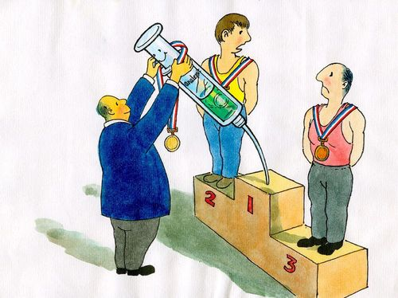

Recently the Russian Olympic team were banned from competing in future Olympic events. This banned was made after the 2014 winter Olympics where most of the Russians were caught doping. Russia were banned from competing in the 2016 summer Olympics in Brazil. But the International Olympic Committee allowed only a hand full of Russians to compete under them. Doping is a serious thing in sport, and we will do everything to prevent it from happening.